End Rhyme

🔹 What is End Rhyme
# Source: Chatgpt (GPT-4-turbo) at [8/2/2025]
⚠️ End rhyme is a poetic sound device, not a formal type of homograph, but homographs may coincidentally participate in end rhyme.

✅ Definition of End Rhyme
# Source: Chatgpt (GPT-4-turbo) at [8/2/2025]
End rhyme occurs when the final syllables or sounds of two or more lines in poetry rhyme with each other.
It is the most common rhyme in poetry and often used to establish rhythm and pattern.

🔊 Key Feature
# Source: Chatgpt (GPT-4-turbo) at [8/2/2025]
- Rhyming words appear at the end of lines in a poem.
- Can include perfect, slant, eye, or other rhyme types.

📝 Examples of End Rhyme in Poetry

✅ Example (Perfect End Rhyme):
# Source: Chatgpt (GPT-4-turbo) at [8/2/2025]

I wandered lonely as a cloud
That floats on high o'er vales and shroud.
Words: cloud / shroud → final sounds rhyme perfectly.

✅ Example with Homographs in End Rhyme:
# Source: Chatgpt (GPT-4-turbo) at [8/2/2025]
The wind began to blow
And scattered leaves below the row.
Word row (homograph: /roʊ/ as line; /raʊ/ as fight) shares sound with blow → Perfect end rhyme.

🧠 How Homographs Relate to End Rhyme
# Source: Chatgpt (GPT-4-turbo) at [8/2/2025]
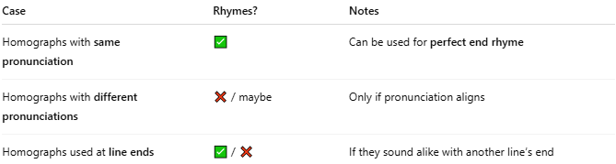
Case | Rhymes? | Notes
Homographs with same pronunciation | ✅ | Can be used for perfect end rhyme
Homographs with different pronunciations | ❌ / maybe | Only if pronunciation aligns
Homographs used at line ends | ✅ / ❌ | If they sound alike with another line’s end

📊 Comparison Table
# Source: Chatgpt (GPT-4-turbo) at [8/2/2025]
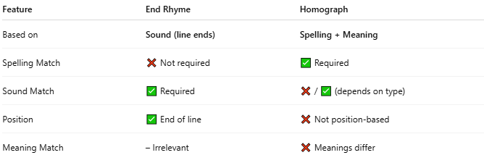
Feature | End Rhyme | Homograph
Based on | Sound (line ends) | Spelling + Meaning
Spelling Match | ❌ Not required | ✅ Required
Sound Match | ✅ Required | ❌ / ✅ (depends on type)
Position | ✅ End of line | ❌ Not position-based
Meaning Match | – Irrelevant | ❌ Meanings differ

🔁 Common Overlap
# Source: Chatgpt (GPT-4-turbo) at [8/2/2025]
Sometimes, homographs are used at line ends and happen to rhyme—creating end rhyme coincidentally.
For example:
- “Lead” (metal) rhyming with “dead”
- “Read” (past tense) rhyming with “red”

✅ Conclusion
# Source: Chatgpt (GPT-4-turbo) at [8/2/2025]
- End rhyme is not a type of homograph but a rhyme position in poetry.
- Homographs can appear in end rhymes if their pronunciation matches rhyming lines.
- Especially relevant in poetry, songwriting, and phonetic wordplay.

